Idaho Falls American Legion Post 56
Quilts of Valor Presentation to Roberta Bugbee

During a regular meeting of Idaho Falls American Legion Post 56 on February 21, 2022, Ms. Mimi Jones, of the Quilts of Valor organization, was a guest at our meeting. They make and distribute quilts of warmth and comfort to active duty and veterans of our country’s military -- almost 300,000 quilts have been presented.

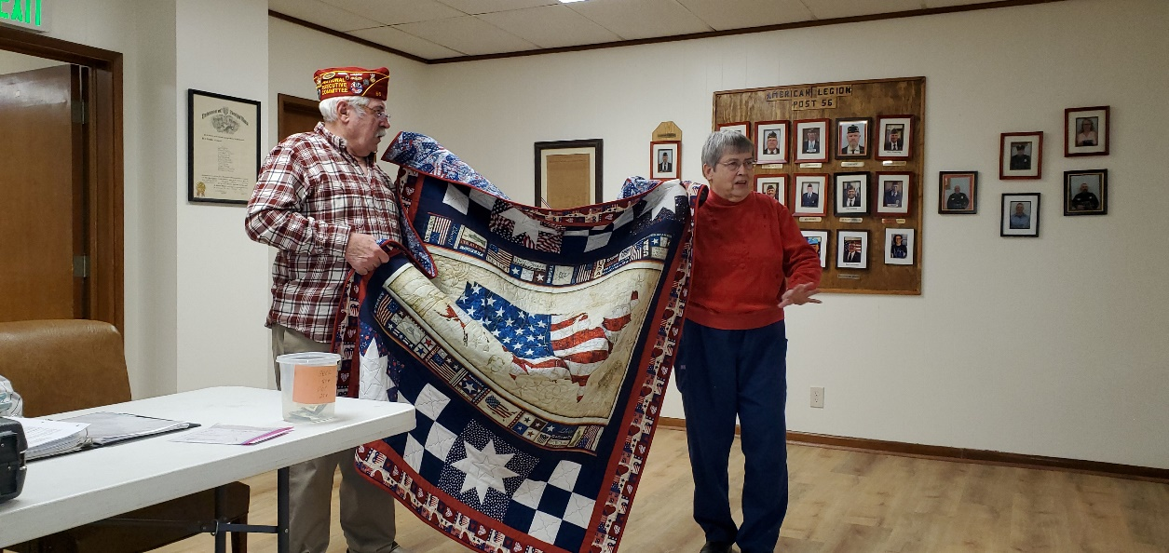

Mimi presented a Quilt of Valor to one of our active Post members, Roberta Bugbee. She is an active member within the Post and of the American Legion Memorial Team. Roberta was completely surprised! What a terrific honor.

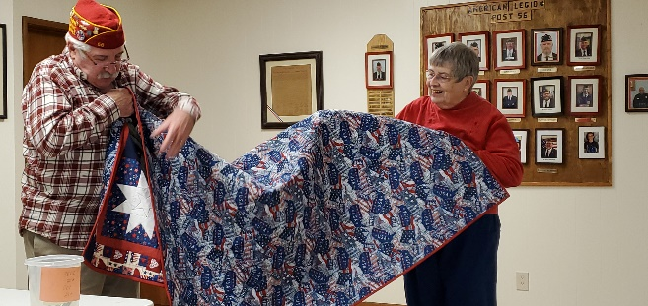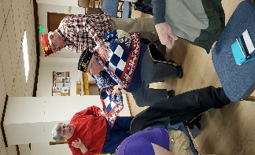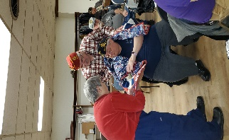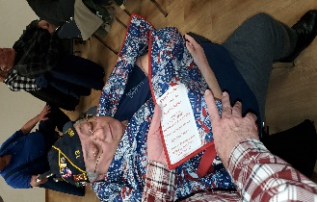

Congratulations, Roberta and thank you for your service!

